

**DEPARTMENT OF**

**ELECTRICAL ENGINEERING**

LAB REPORT OF EEE-401

(Academic Year: 2021-2022)

**Design and Simulation of Electrical Systems**

**Load-Frequency Control**

**SUBMITTED BY**

1. Gyanendra (18085026)

2. Anshita Vijayvargiya (18085011)

3. Aman Singh (18085008)

**UNDER THE GUIDANCE OF**

**Prof.** Dr. Maria Thomas

Department of Electrical Engineering

**LOAD FREQUENCY PROBLEM**

If the system is connected to numerous loads in a power system, then the system frequency and speed change with the characteristics of the governor as the load changes. So, if constant frequency is required the operator needs to adjust the velocity of the turbine by changing the characteristics of the governor when required.

**SPEED GOVERNING SYSTEM**

1. MATHEMATICAL MODELLING OF LOAD:

The model gives relation between the change in frequency as a result of change in generation when the load changes by a small amount.

The block diagram representation of the generator-load model is: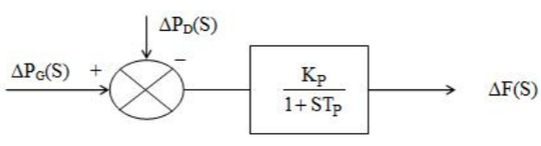

Figure 1: Mathematical modelling Block Diagram of Load

From the above block diagram we have

F(s) = [△PG(s) - △PL(s)] Df0

Where, Tp = = power system time constant

And Kp = = power system gain.

1. MATHEMATICAL MODELLING OF TURBINE MODEL:

The turbine model requires a relation between changes in power output of the steam turbine to changes in its steam valve opening △XE.

GT(s) = =

Thus the model representation of the turbine the transfer function is:

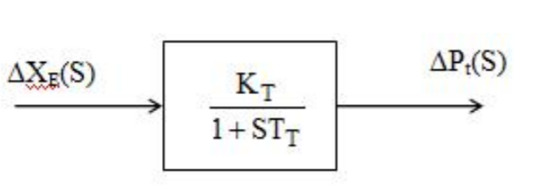

Figure 2: Mathematical modelling Block Diagram of Turbine Model

1. MATHEMATICAL MODELLING OF GOVERNOR MODEL:

Speed governor model can be developed by considering various steady state conditions. The resulting speed governor model is:

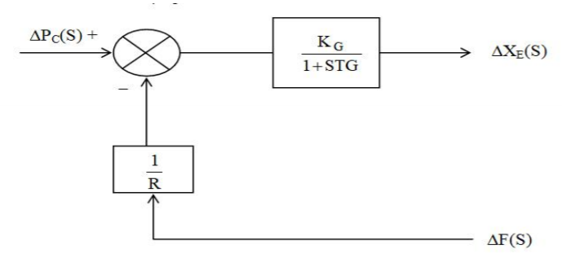

Figure 3: Mathematical modelling Block Diagram of Load

From the above block diagram we can get the following expression:

△XE(s) = [△PC(s) - △F(s)]

Where,

R = Speed regulation of the governor

KG = Gain of speed governor

TG = time constant of speed governor

1. TRANSFER FUNCTION OF SINGLE AREA SYSTEM:

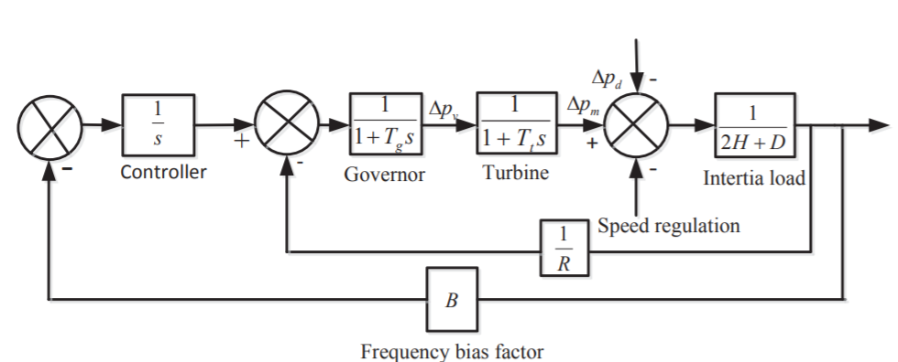

Figure 4: System block scheme using PID controller

Combining all the above block diagrams, close loop transfer function for an isolated single area system that relates the load change △PL(s) to the frequency deviation Ω(s) is :

**=**

**SELECTION OF PARAMETERS** (From **Power System Analysis by Hadi Saadat**)

Let an isolated power station has the following parameters.

1. Turbine Time Constant, Tt = 0.5 seconds,
2. Governor Time Constant, Tg = 0.2 seconds,
3. Generator Inertia Constant, H = 5 seconds,
4. The governor speed regulation is set to R = 0.05 per unit. The turbine rated power is 300 MW at nominal frequency of 60 Hz. A sudden load change of 50 MW (ΔPL = 0.2 per unit) occurs.
5. The load varies by 0.8 percent for a 1 percent change in frequency,

i.e. D = 0.8.

**COMPARISON OF DIFFERENT CONTROL METHODS**

In the power system, the system load keeps changing from time to time according to the needs of the consumers, which leads to the change in frequency of the grid. So designed controllers are required for the regulation of the system variations in order to maintain the stability of the power system and its reliable operation.

The proposed artificial neural networks controller shows that the proposed controller can generate an improved dynamic response for a step load change in comparison to the PID (Tuned P = 0.767, I = 0.172, D =0.440) controller or without any controller.

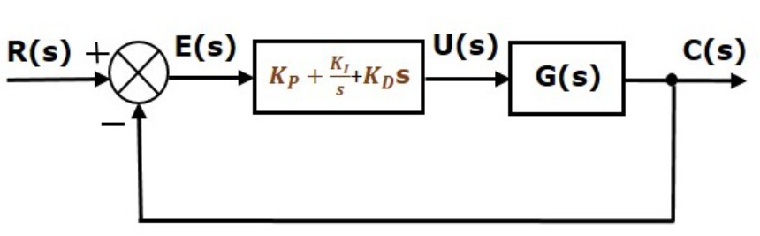

Figure 5: Block diagram of PID controller structure

The PID controller has following transfer function:

u(t)=KPe(t) + KI ∫e(t)dt + KD

= KP+KI s+KD s

The artificial neural network takes input from the PID input terminal and computes the weighted sum of the inputs and includes a bias. This computation is represented in the form of a transfer function.

Z = ωiХ

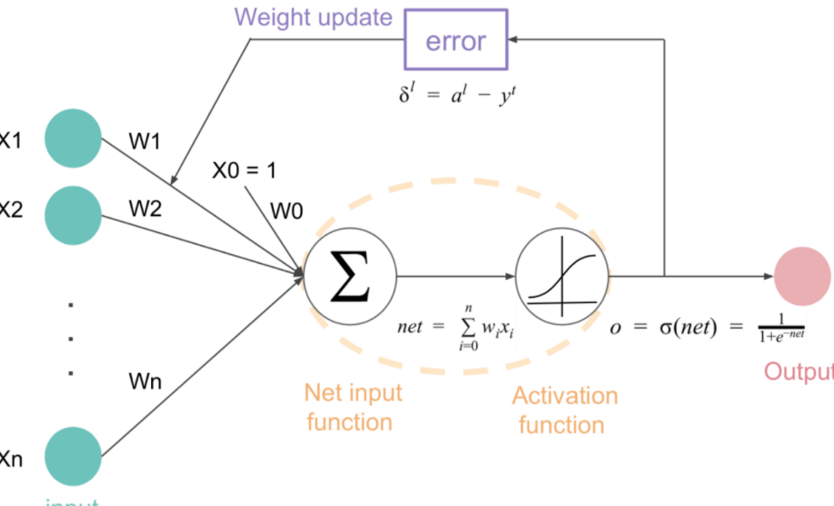

Figure 6:Neural Network Architecture

Since this is a classic regression problem for input-output relation of PID controllers. The use of **Adaptive Moment Estimation (or Adam)** Optimiser can prevent gradient descent stuck at local minima and RMSProp changes the learning rate as per the cost function. Taking the formulas used in the gradient descent and RMSprop, we get;



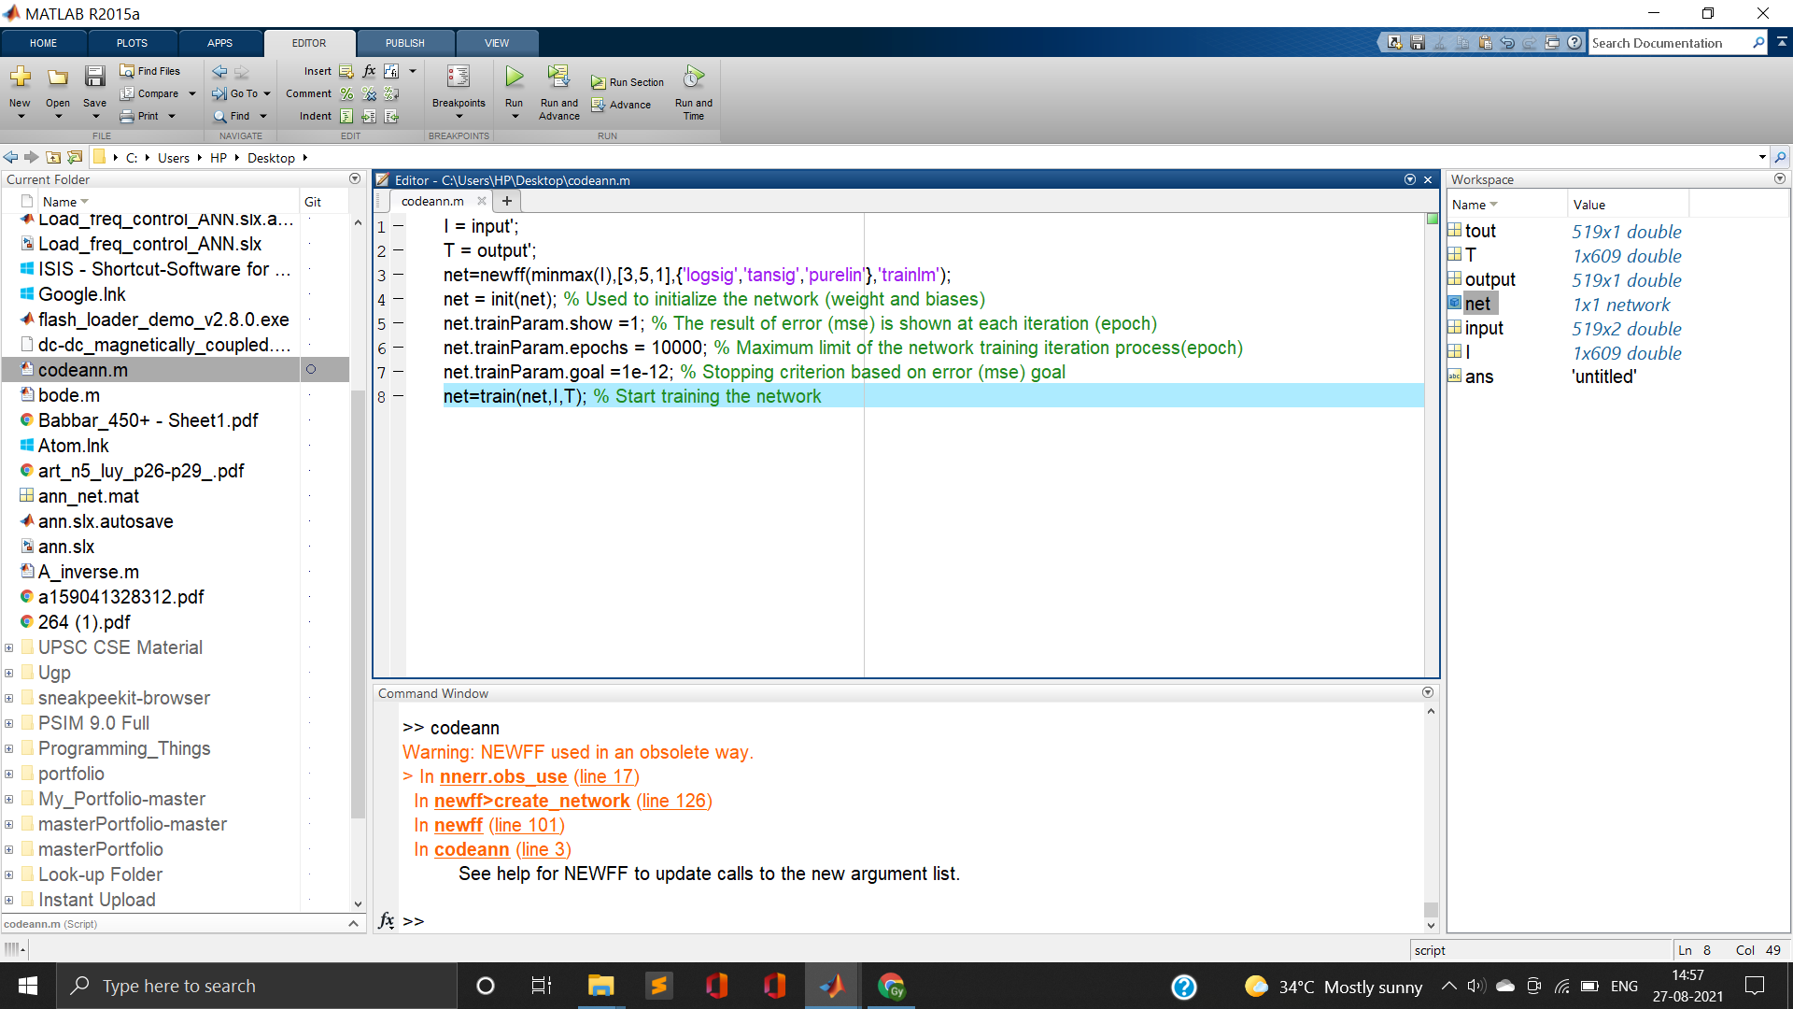

Figure 7: ANN code in MATLAB

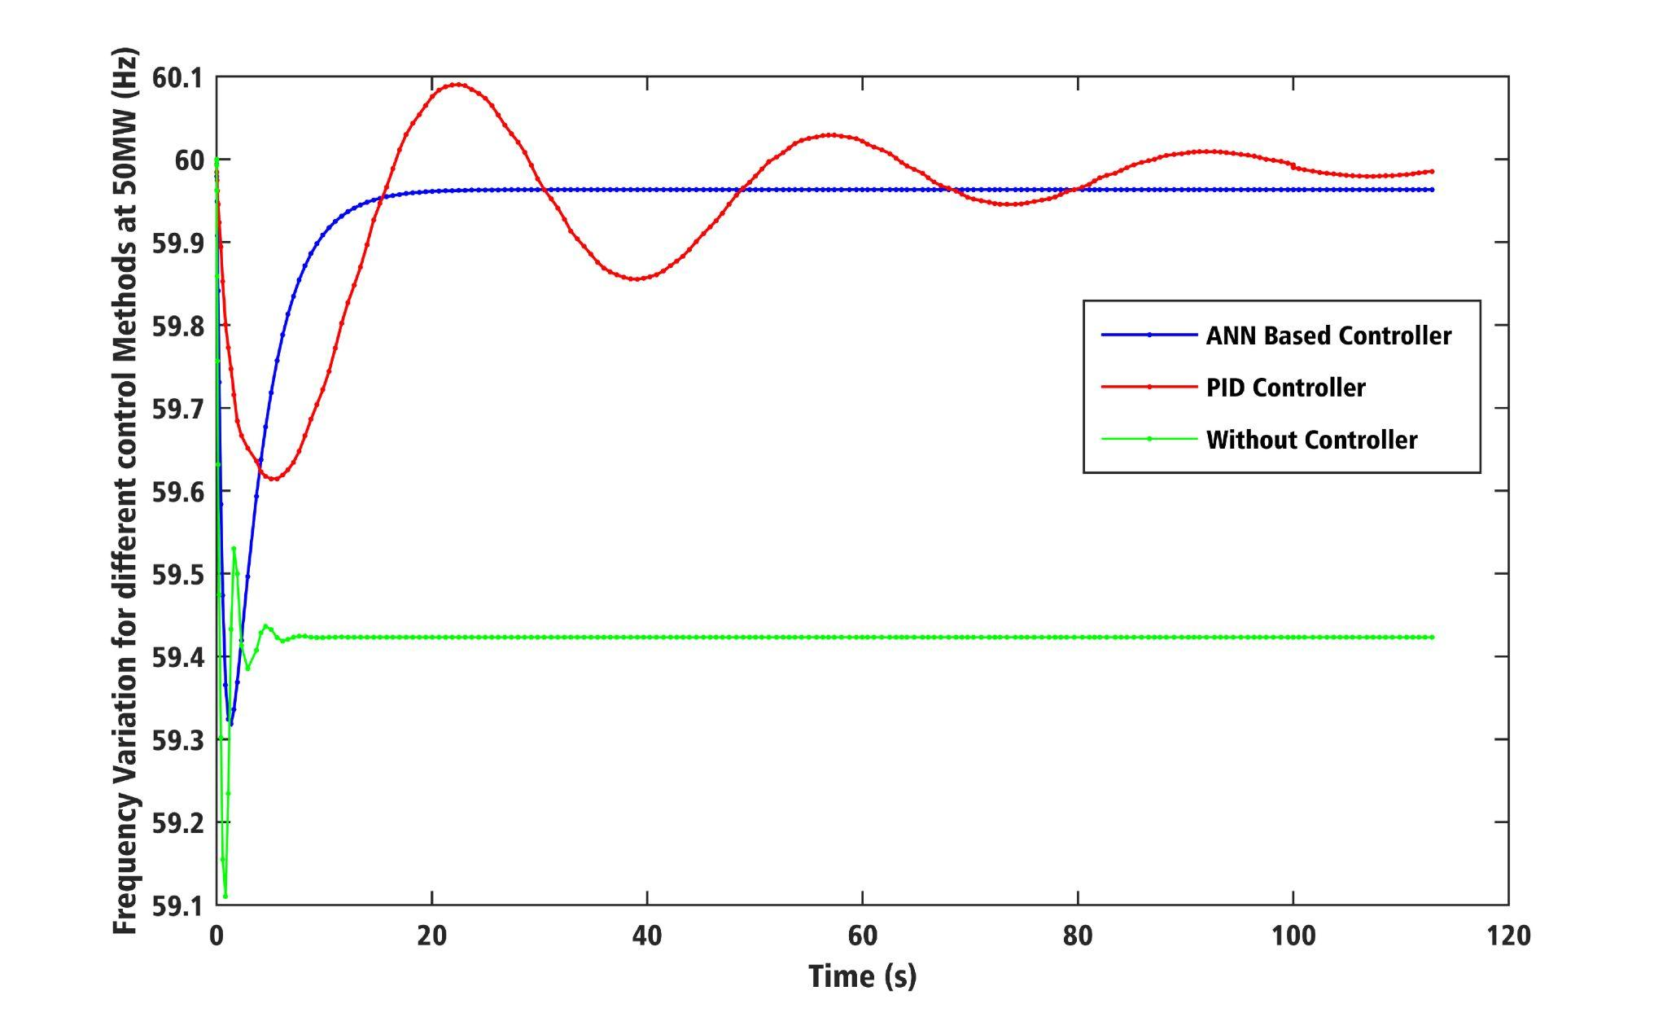

Figure 8: Different Control Schemes

**CIRCUIT DIAGRAM**

Figure 9: Load frequency control using ANN based controller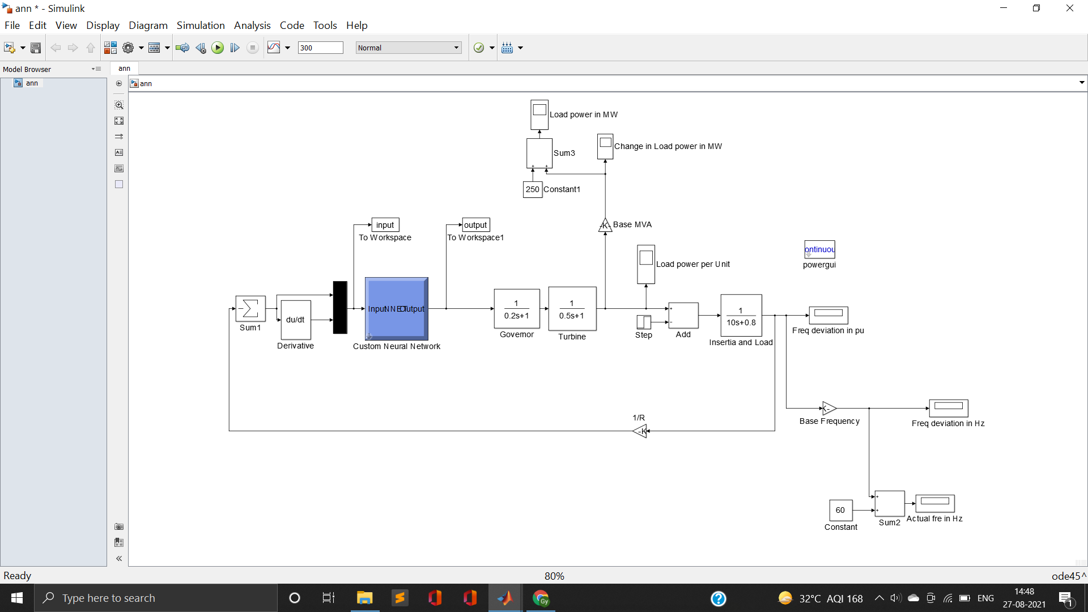

**LOAD VARIATION**

|  |  |  |
| --- | --- | --- |
| **Sudden Load Change** | **△PL p.u. (TL = 250MW)** | **PL’ = △PL + PL** |
| 55(iii) | 0.22 | 305 |
| 52(iv) | 0.208 | 302 |
| 50(i) | 0.20 | 300 |
| 60(ii) | 0.24 | 310 |
| 58(v) | 0.232 | 308 |

Table 1: Load variation data

FREQUENCY LOAD VARIATION USING ANN BASEDCONTROLLER:

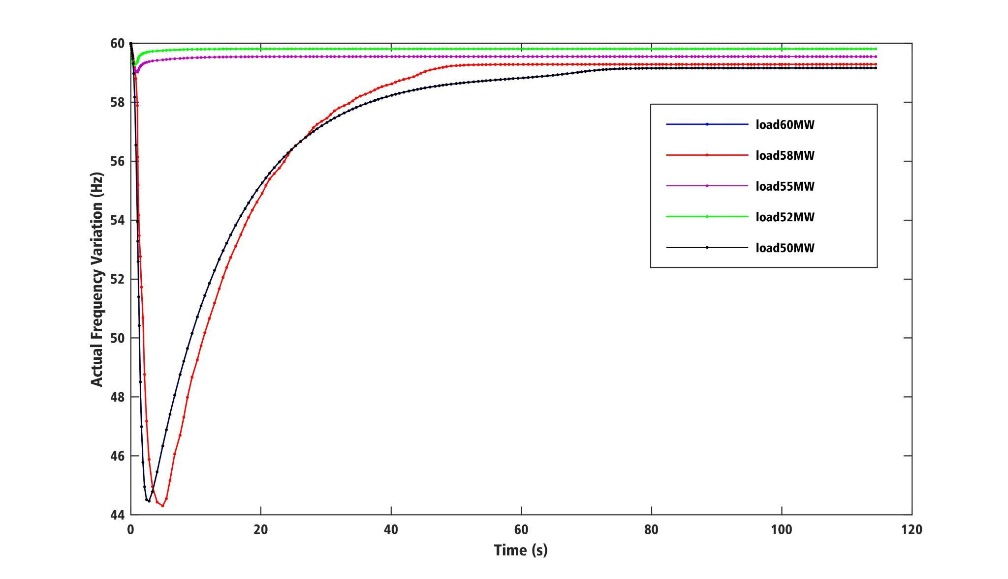

Figure 10: Actual Frequency at different Loads

**CONCLUSION**

From the simulation results obtained for load disturbances for ANN controller, PID controller we can conclude that the settling time and overshoots with the proposed ANN controller are much shorter than that with the conventional PID controller.

Variation of Frequency is also analysed at various loads (i.e. at 60MW, 58MW, 55MW, 52MW and 50MW) which shows proposed Artificial Neural Network based controllers attain steady state with good dynamic response.